"A Voyage to Space: China’s Manned Space Expedition" Special Exhibition Activity Sheet
(Primary Level)
Since its inception, China’s Manned Space Program has made remarkable strides in a number of manned spaceflights, in-orbit astronaut stays and the construction of a space station. This exhibition showcases the journey of astronauts from training to their missions aboard the Tiangong Space Station. It also highlights their work and achievements in conducting scientific experiments on the space station and performing extravehicular activities. Let’s delve into the fascinating journey of astronauts on "Tiangong"!

Becoming an Astronaut
To prepare for the complex and dangerous tasks performed in the extreme environment of space, astronauts must undergo long-term and rigorous training. Experience astronaut training programmes at the "Becoming an Astronaut" exhibition zone, and answer the questions below.
1) What year marked the official launch of China's Manned Space Program?

A) 1990
C) 1997
B) 1992
D) 1999
Answer:
The digital panel of "Complete Training Log of Astronauts" and text panel of "A Taste of Weightlessness" introduce information on how Chinese astronauts are trained. Fill in the blanks below with the correct answers.
2) Chinese astronauts are required to receive training programmes in phases, with more than 200 training tasks under eight key areas, to ensure astronauts are well-equipped with necessary professional knowledge and skills.
3) Why is it necessary for astronauts to have underwater training in a large pool (neutral buoyancy pool)?
The water buoyancy in the pool allows astronauts to familiarise themselves with the __________________in space. The astronauts will wear an underwater training suit that is similar to an __________________________ to practice body coordination and control in the pool to master the necessary skills required for space activities.
💭 Think About It: Here are some examples of Chinese astronaut training programmes. Which one would you most like to try?
- Computer Operation and Maintenance Training
- Underwater Training
- Manual Rendezvous and Docking Training
- Centrifuge Training
- Spacecraft Operation Procedures Training
- Lifesaving Drill at Sea

Tiangong Space Station
Operating approximately 400 kilometres above the Earth’s surface, the Tiangong Space Station not only serves as a home to the astronauts but also as a space scientific laboratory.
4) The Tiangong Space Station can be flexibly assembled in-orbit like building blocks. Observe the space station model displayed at "Docking with Tiangong" and fill the names of the modules and spacecraft into the boxes below.
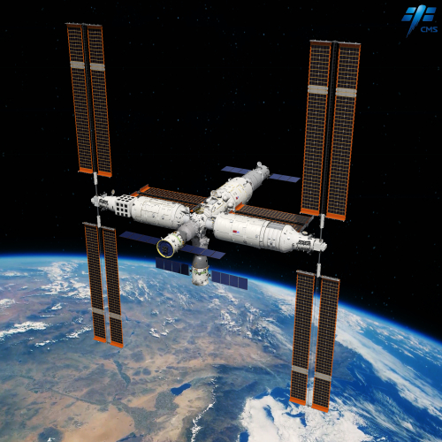
____________

Lab Module
_____________

Core Module
______________

Cargo Spacecraft
_______________

Lab Module
________________

Manned Spacecraft

💭 Think About It: What is the purpose of installing multiple sets of large solar panels to the Tiangong Space Station?
5) Go explore the "Infinity and Beyond" exhibition zone to learn about the planarian experiment in space, then fill in the blanks with suitable words.
Regenerative | Eyespots
Head | Repair

- The Shenzhou-20 manned spacecraft carried the planarians to the Tiangong Space Station for research. Why did the scientists conduct the planarian experiment in space?

Planarians possess exceptional ___________________ abilities. Scientists aimed to understand how space conditions affect _________________ abilities of organisms from the planarian experiment in space.

b) Use the microscope to observe the planarian specimen. Then, refer to the panel text and fill in the boxes below with the body parts of the planarian.
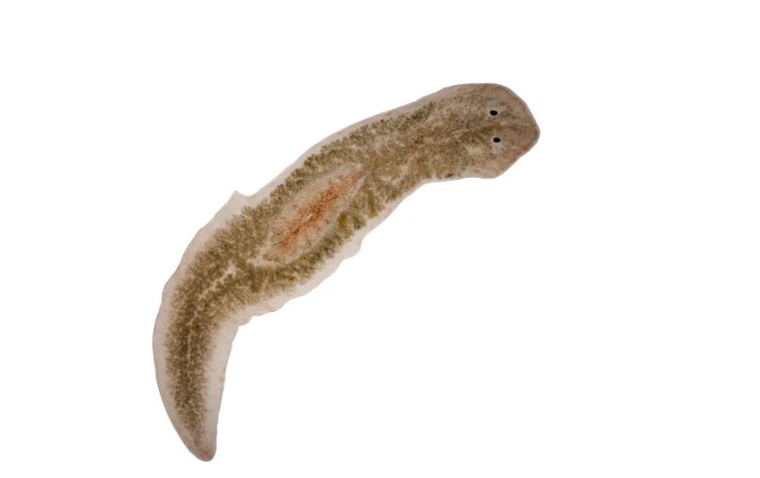

6) Go explore the "Tiangong Aquarium" exhibition zone to learn about the zebrafish experiment in space, and complete the following questions.
a) Zebrafish were sent to the Tiangong Space Station by the Shenzhou-18 and Shenzhou- spacecraft for research. They share over % genetic similarity with humans, making them widely used in biomedical research.

b) The zebrafish were raised with a kind of aquatic plant in a specially designed “space aquarium“. Can you find out the name of the plant from the video and write it into the box below?
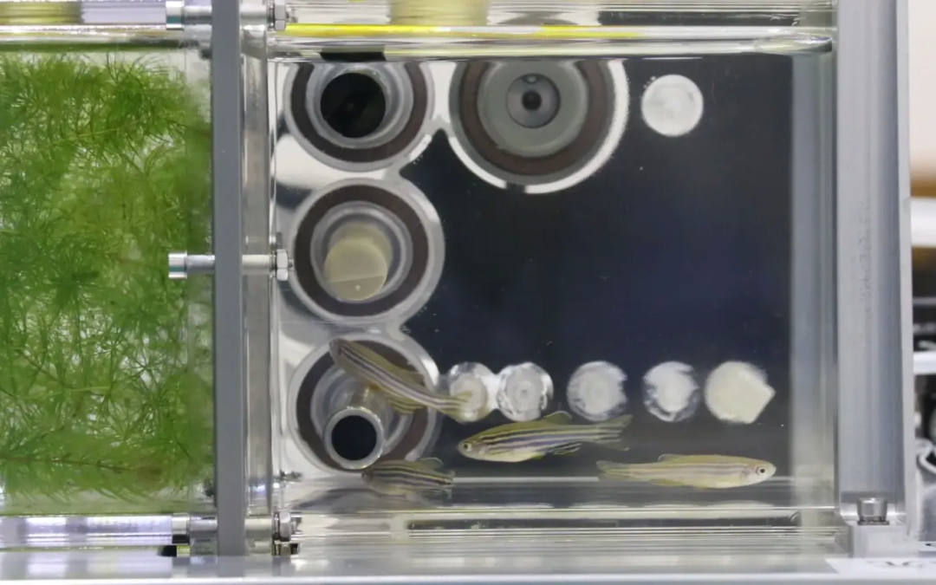

Zebrafish
💭 Think About It: What are the benefits of raising zebrafish together with aquatic plants in the "space aquarium"?

💭 Think About It: Humans experience a disorienting sensation of weightlessness in space. Did the zebrafish exhibit abnormal behaviors when they swam in the weightless space environment? Watch the documentary footage of the zebrafish aboard the Tiangong Space Station, and observe how the fish swam differently in space.

7) Go exlore the "Horticulture in Tiangong" exhibition zone to learn how astronauts grow fruits and vegetables in space. Then complete the following questions.
a) Which of the following is/are the reason(s) for astronauts growing fruits and vegetables on the Tiangong Space Station?

A) As food
C) For relieving astronauts' psychological stress
B) For air purification
D) All of the above
Answer:

b) Which of the following plants have astronauts grown aboard the Tiangong Space Station?

A) Bananas and apples
C) Cherry tomatoes and lettuce
B) Passion fruit and cherry tomatoes
D) Lettuce and passion fruit

Answer:

Spacewalks
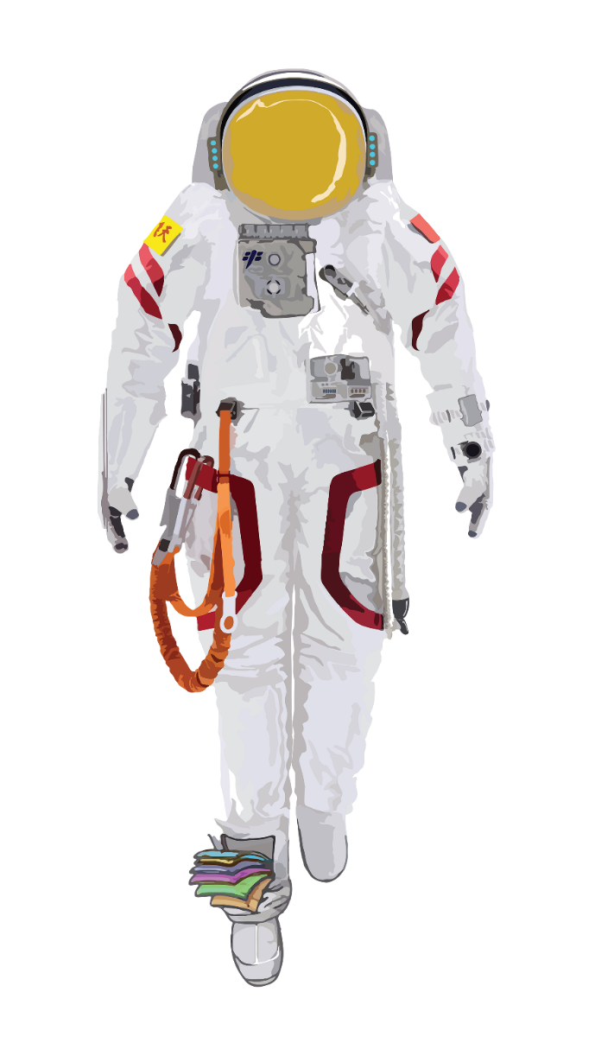
8) To cope with the harsh environment of space, Chinese astronauts will put on the "Feitian" extravehicular spacesuits when stepping out of the space station for extravehicular missions. With reference to the text panel, match different parts of the extravehicular spacesuit by writing the corresponding letters into the boxes below.

- Helmet Visor | - Backpack | - Glove
- Electrical Control Panel | - Boot | - Safety Tether

9) If you became an astronaut, where in the Universe would you want to explore? Why?
________________________________________________________________________
________________________________________________________________________
________________________________________________________________________

